*SIMPLE 2D CAD APPLICATION* Product Design Specification

Team: Insignia Version *<1.0>*

*04/11/2001*

Team Members:

1. MANAN SETHI
2. TASHU CHUGH
3. TANYA GOYAL
4. Abhijeet Singh HADA
5. SHIVAM TYAGI

**TABLE OF CONTENTS**

1. **INTRODUCTION**
   1. WHAT IS 2D CAD?
2. **FUNCTIONAL SPECIFICATION**
   1. FEATURES
   2. SYSTEM REQUIREMENTS
   3. SCENARIOS
3. **EXTERNAL USER INTERFACE**
   1. USE-CASES & ADVANTAGES
   2. USER INTERFACE DESIGN
4. **TECHNICAL SPECIFICATION**
   1. HARDWARE DETAILS
   2. SOFTWARE ARCHITECTURE
5. **INTRODUCTION**
   1. WHAT IS 2D CAD

CAD is a valuable tool for designing simple project blueprint. For rough basic sketches of the idea, one wants to implement. It can help assist with the design’s creation, modification, analysis, or optimization of a design. 2D CAD can be used across a wide range of industries such as automotive, aerospace, fashion and industrial design. It helps increase productivity of a designer. It can be used to design Curves and figures in two-dimensional, and for accurate creation of photo simulations.

Some of the UI designer can also use the tool for making some rough sketches of what they are trying to make and what they have in their minds.

2D CAD can be used across a wide range of industries such as automotive, aerospace, fashion and industrial design. Helps increase productivity of a designer. It is used to design Curves and figures in two-dimensional and is used for accurate creation of photo simulations.

CAD 2D is a free intuitive painting and drawing application designed for people of all skill levels, who love to draw. This is a very easy program to use to Create or Modify an existing picture useful for tablets or mobile phones and a wonderful drawing program for all ages to free your imagination and inner artist.

1. **FUNCTIONAL SPECIFICATION**
   1. FEATURES
2. Assist with the design’s creation, modification, analysis, or optimization of a design.
3. Handling objects such as shapes (for now, circles, quadrilaterals and lines) and layout for different applications.
4. Designs can be copied and pasted easily from
5. Drafting views such as planes, sections, and elevations, designers can visualize completed design and make any amendments as needed.
6. Software is much faster than manual drawing methods, it also allows designers to explore different design options more efficiently.
7. Being able to insert commonly use components into a drawing greatly speeds up the drawing process while also removing the potential for errors.

2.2 USE-CASES AND ADVANTAGES:

**Easy to Use**

2D-CAD drawing software has the CAD tools you need to make scaled drawings of all kinds. Start with any of the built-in CAD templates and drag and drop symbols. You can set the size of walls or objects by simply typing into the dimensions label. You can also set the specific angle between two walls.

### Easy to Find the Symbols You Need

2D-CAD includes a vast collection of symbols for every type of CAD drafting project.

### Easy to Work with Other Apps

2D-CAD is easy to work with no matter what other apps you use. You can add CAD drawings to:

* Microsoft Office®
  + Word®
  + PowerPoint®
  + Excel®
* Microsoft Teams®
* Google Workspace™
  + Google Docs
  + Google Sheets
* Atlassian™ apps
  + Confluence
  + Jira

**Easy to Save to Your Existing Storage Solution**

CAD works hand in glove with most file storage systems. You can save your CAD drawings directly to:

* SharePoint®
* OneDrive®
* Google Drive™
* DropBox®
* Box®

There is no need to create a parallel set of common folders and permissions, 2D-CAD application can just save files directly into your existing set up. You can spend less time managing software and more time on making CAD drawings.

### Easy to Share

Share your CAD drawing with anyone, even if they don't own a copy of this app. You can easily export any diagram as a PDF or common image formats like PNG.

**Entertainment and learning purpose**

2D-CAD is a multipurpose desktop application can also be used by the children for learnings and also for fun activities. Children can draw different shapes, sceneries and other drawings and enjoy this app in their own way as it also helps in improving their thinking skills. It is something amusing which one can use in there unfastened time and additionally get their palm on even as they're learning to create beautiful things that can in addition create consciousness for their careers in future.

We’ve already touched on some of the many applications of CAD, but now let’s take a more detailed look at some of the most common and significant uses of CAD software.

**Graphic Design**

2D CAD software is used by graphic designers to create visualizations, as well as add effects, shapes, typography and backgrounds to their visuals.

**Construction**

In construction, CAD software can be used to make simplify blueprints and provide uniform measurements, as well as making adjustments when the project is in process. It can also digitize construction sites and link project information from design to construction.

### Engineering

CAD is a valuable tool to engineers for designing simple project blueprint. For rough basic sketches of the idea they want to implement. Some of the UI designer can use the tool for making some rough sketches of what they are trying to make and have in their minds.

1. **EXTERNAL USER INTERFACE**
   1. USER INTERFACE DESIGN

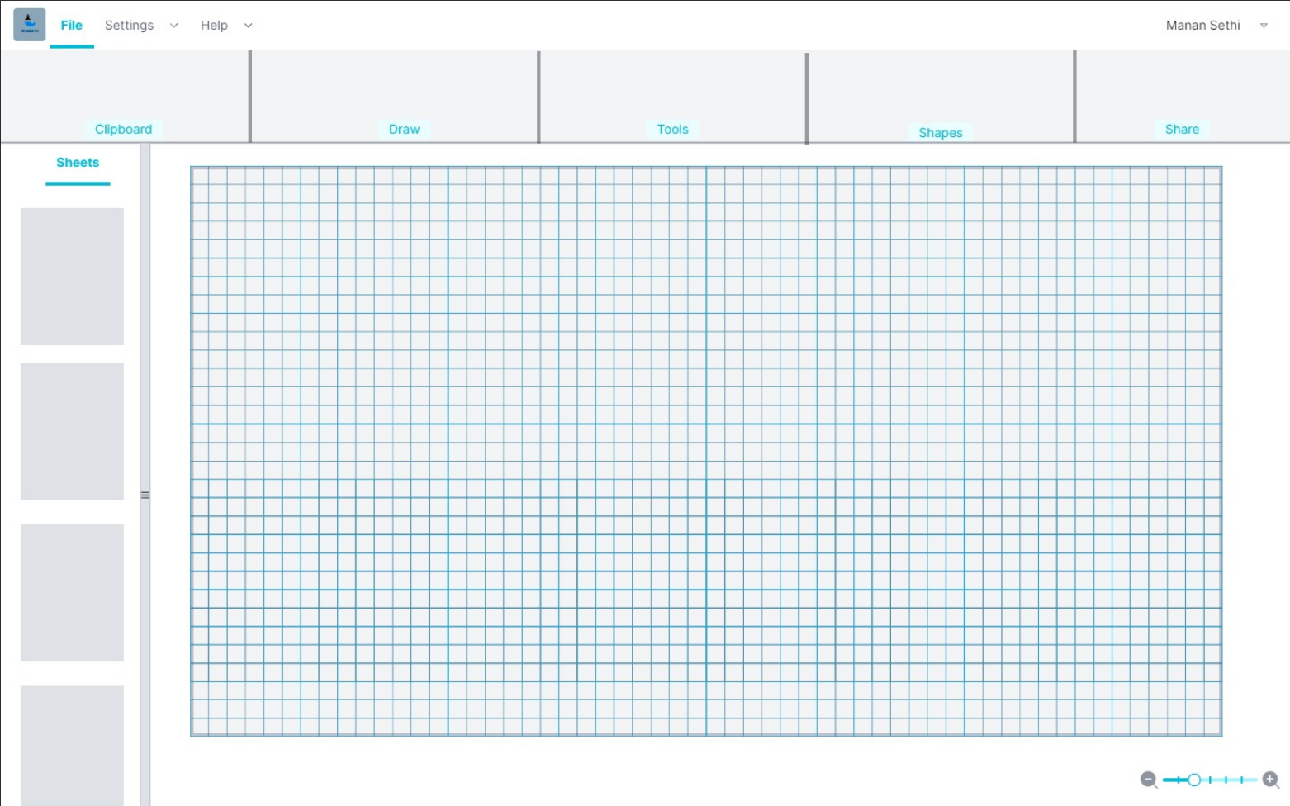

**CREATING A CIRCLE:**

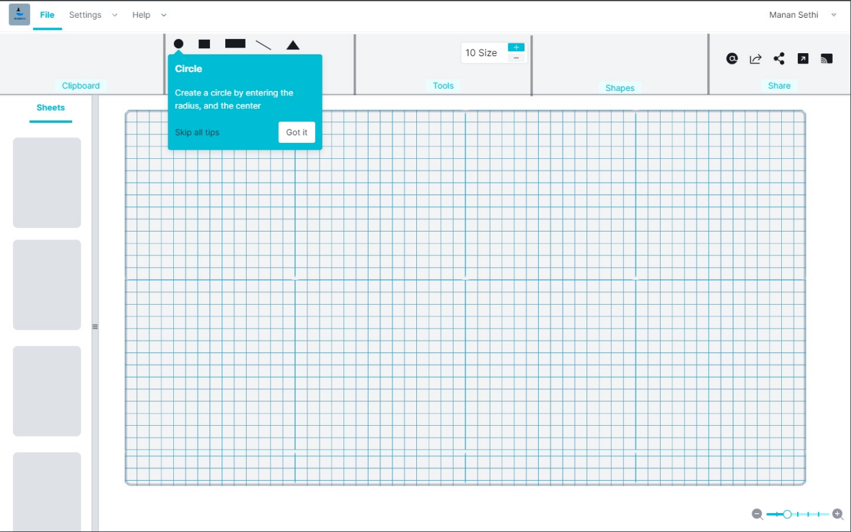

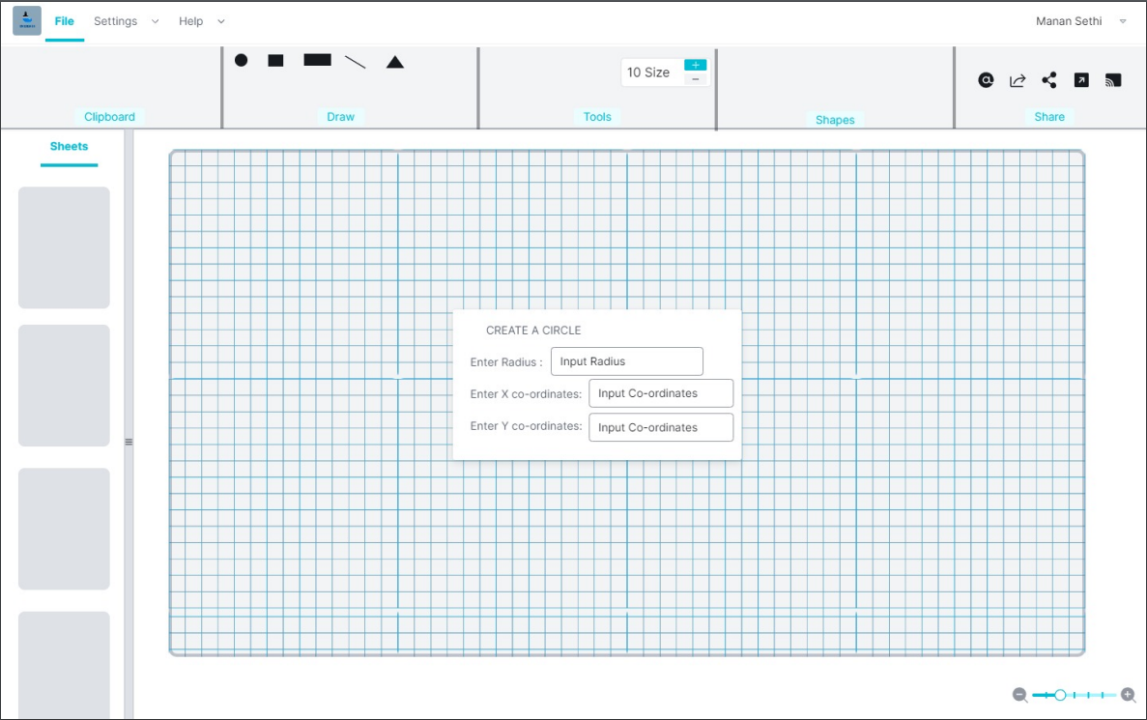

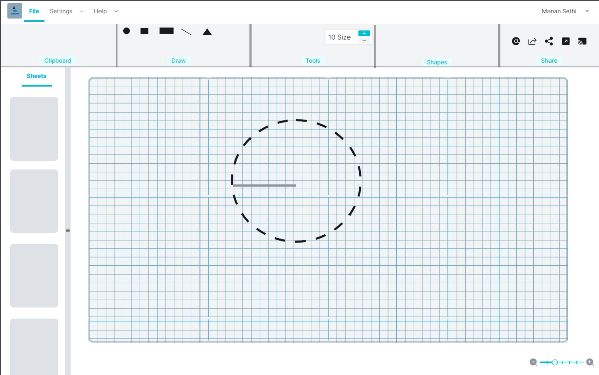

**CREATING A RECTANGLE**

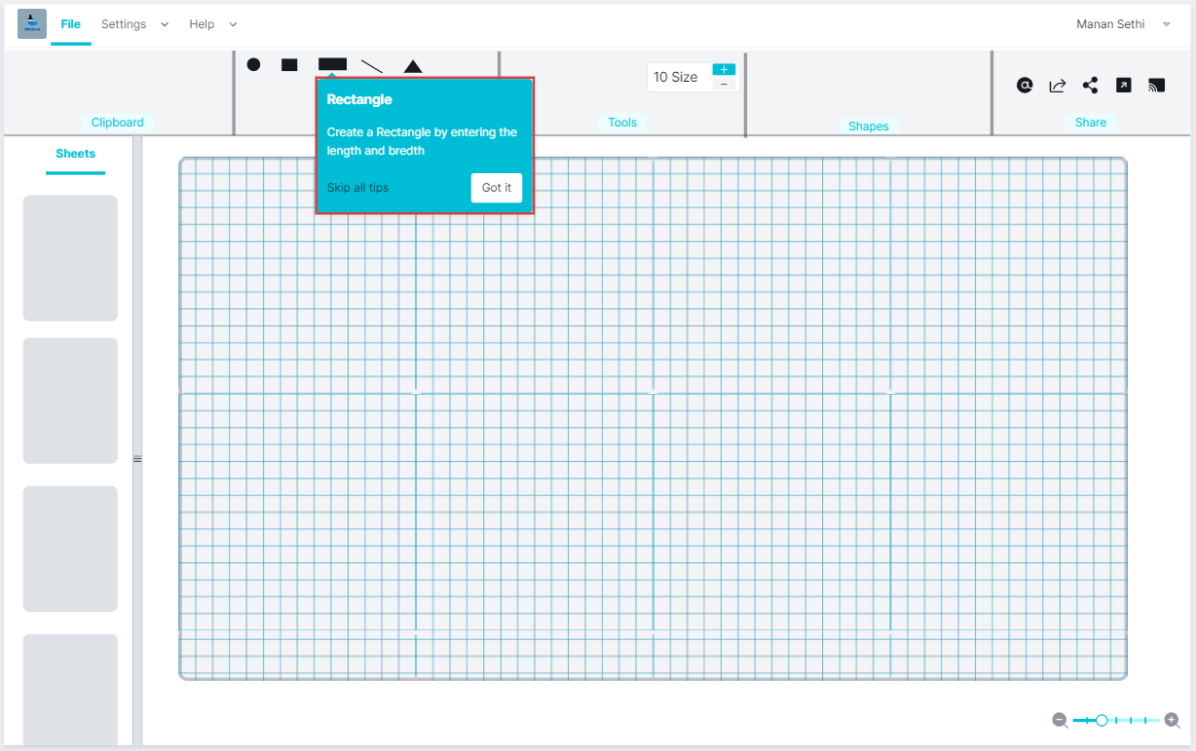

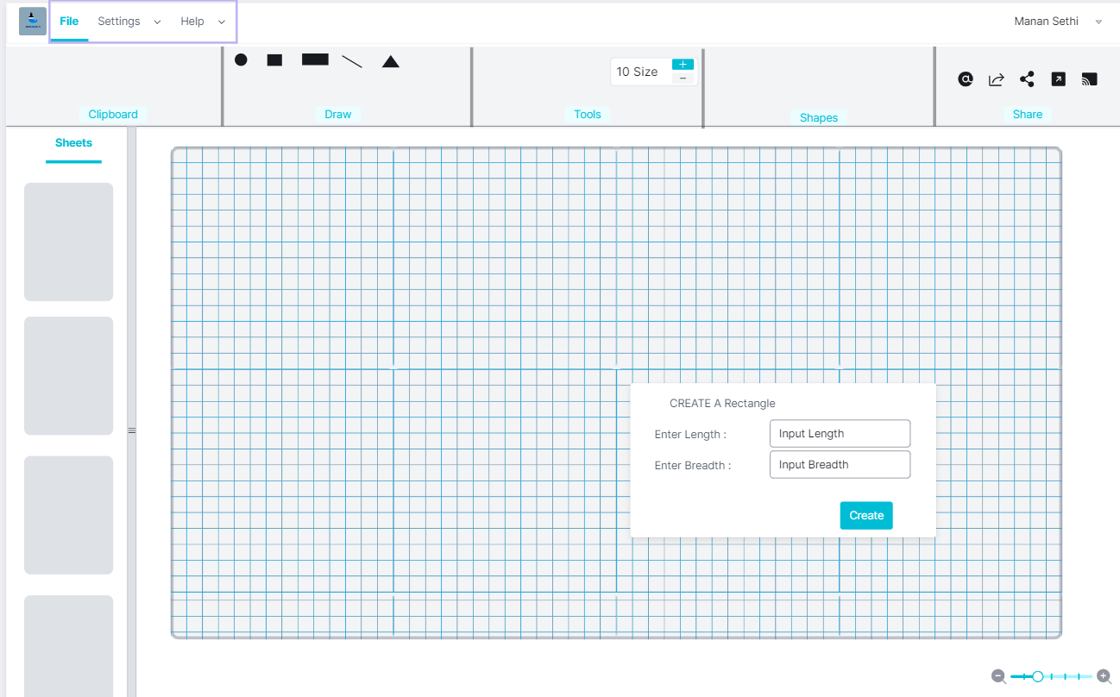

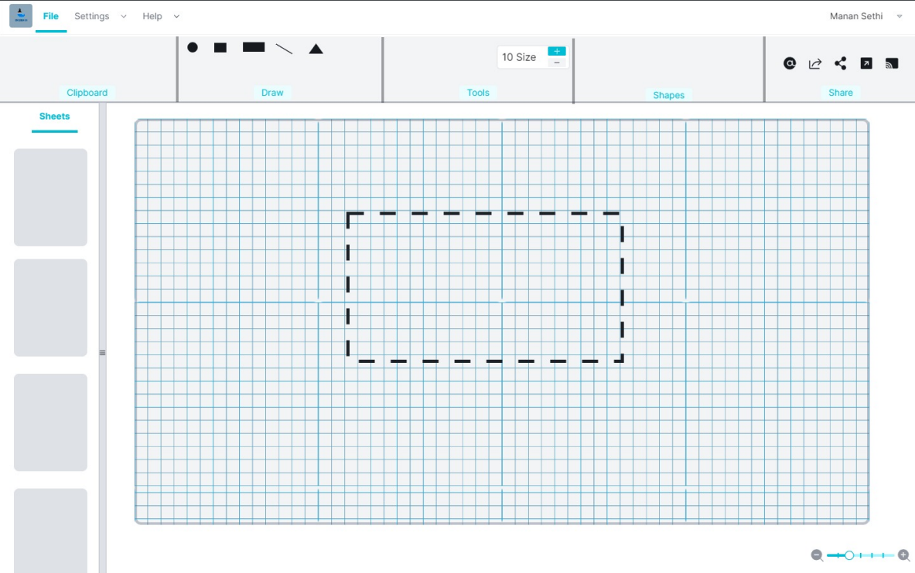

**CREATING A SQUARE**

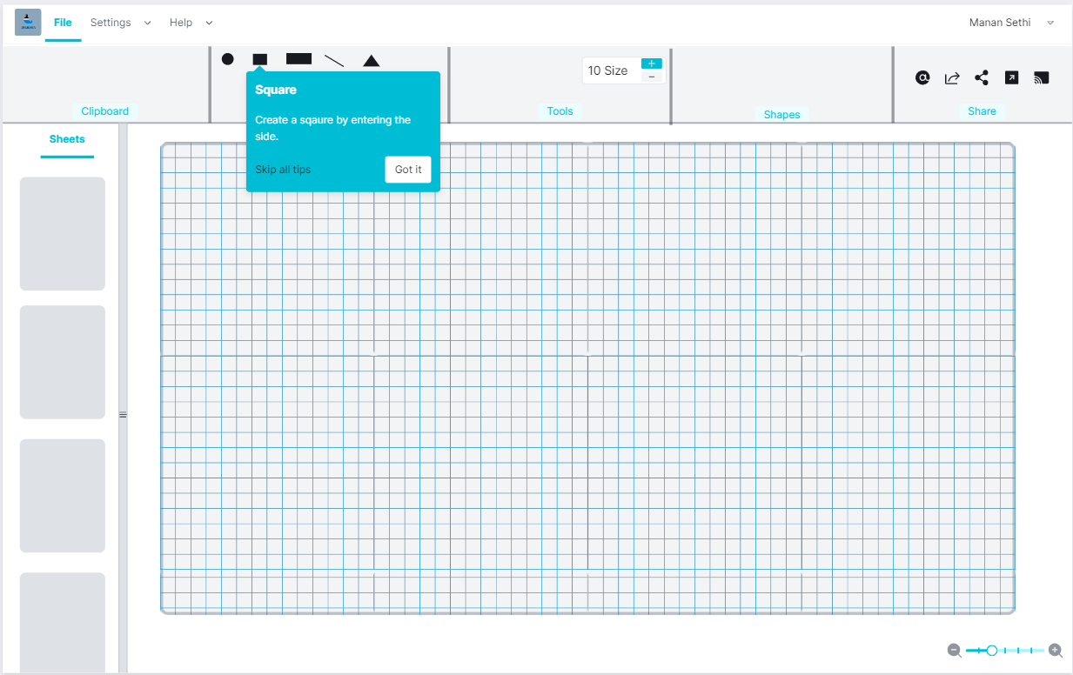

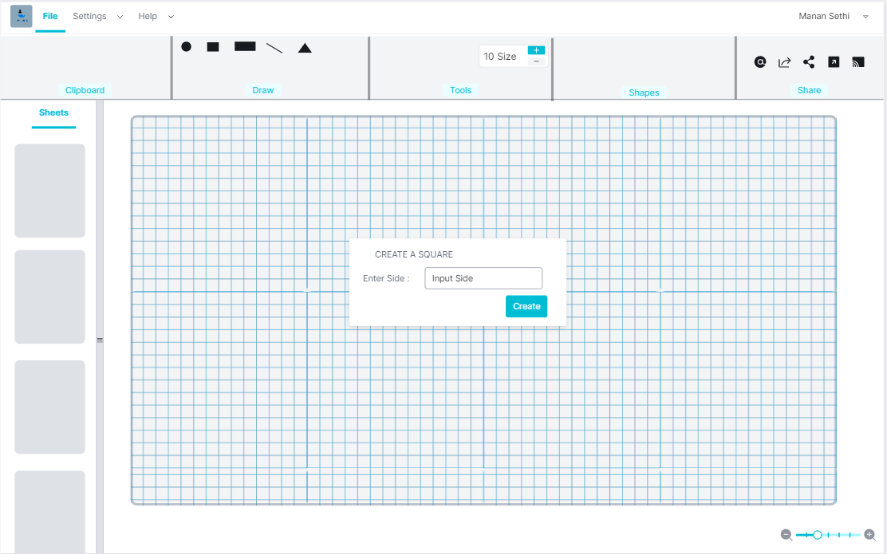

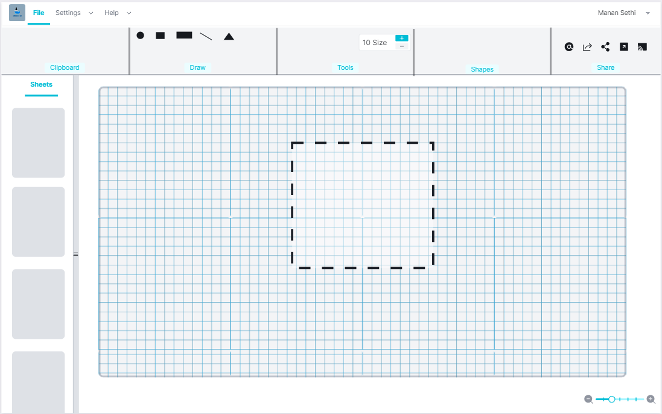

**CREATING A TRIANGLE**

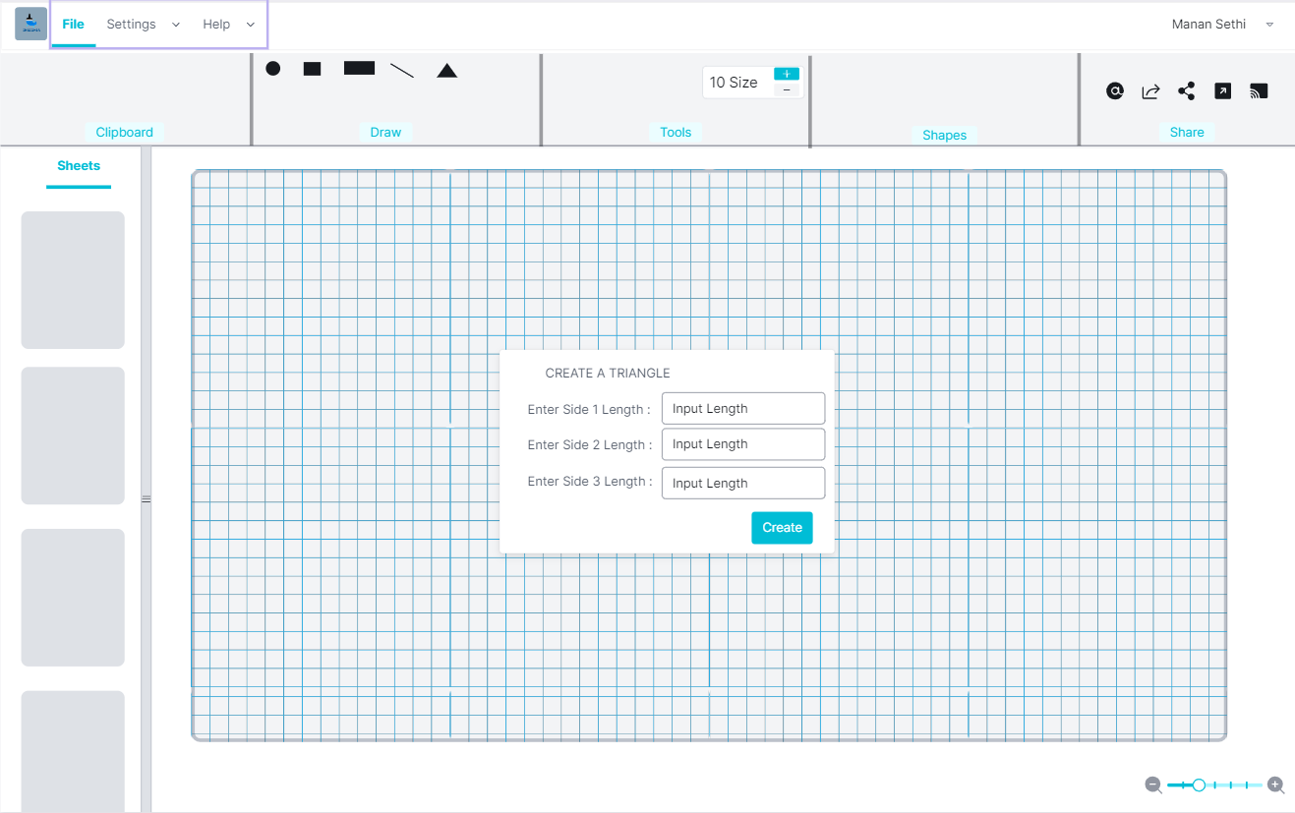

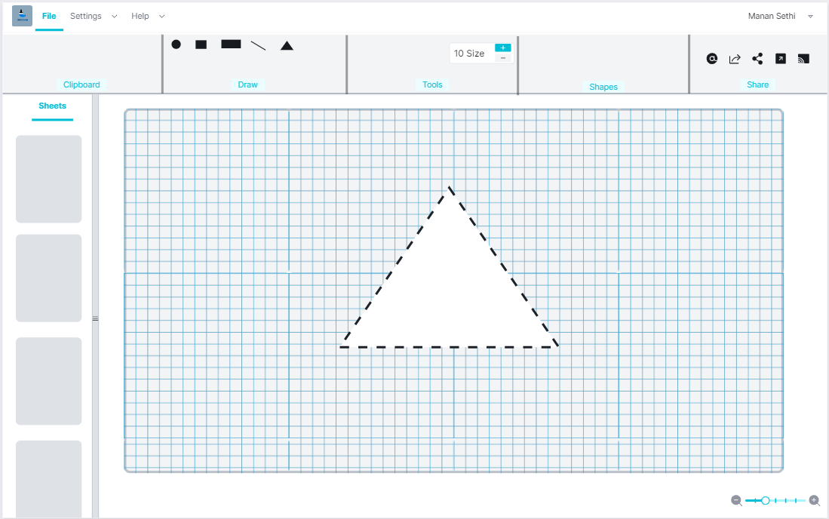

**COPY AND PASTE FUNCTIONALITY**

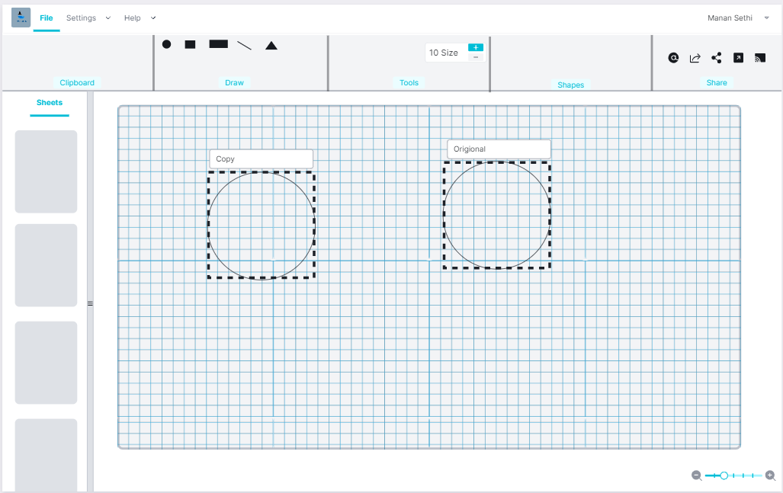

**OPENING & SAVING FILES**

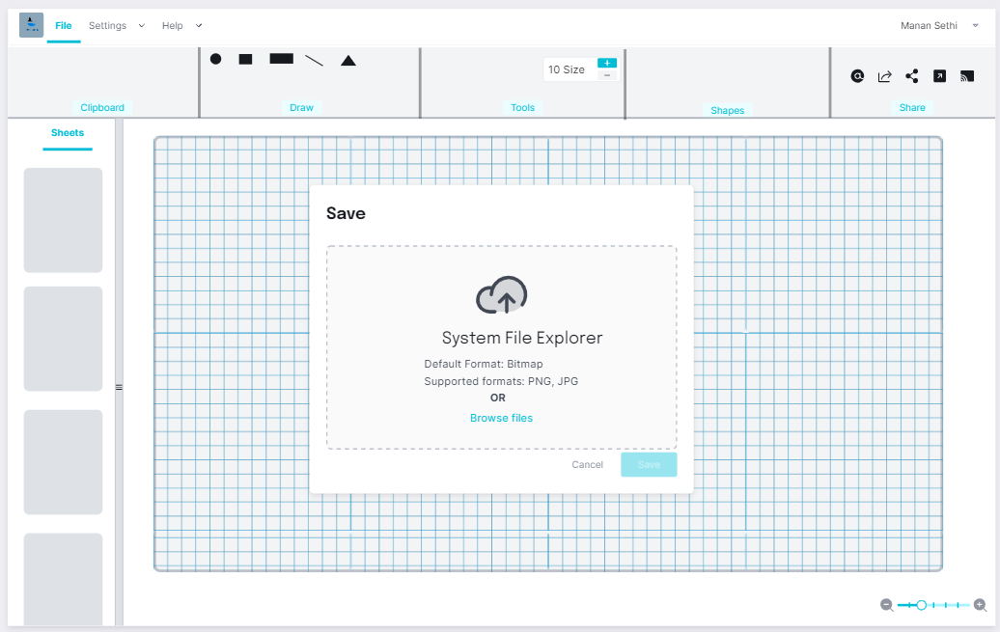

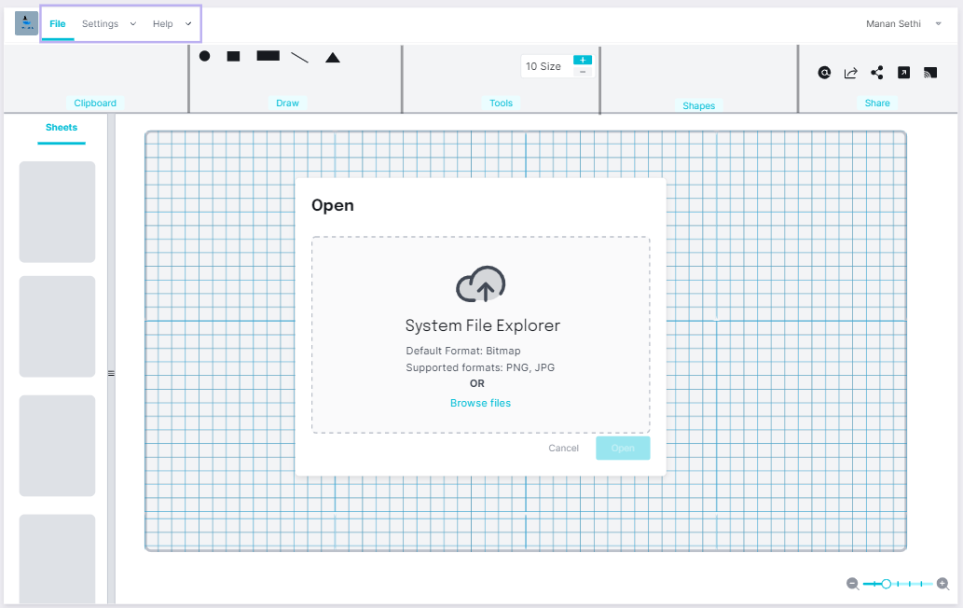

**MOVE FIGURES:**

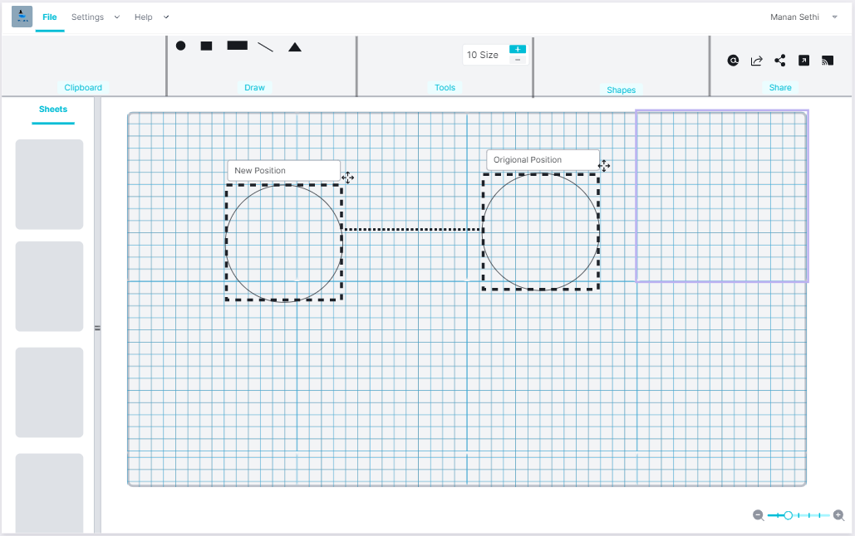

1. **TECHNICAL SPECIFICATION**

* **Hardware detail**

Any dual core and higher processor

RAM greater than 64 MB

* **Operating System**

Window 7 and above

* **Performance**

Optimal performance as the app doesn’t requires much RAM,

**Software Architecture:**

Cartesian plane:

The Cartesian plane to be made is to have four quadrants that are:

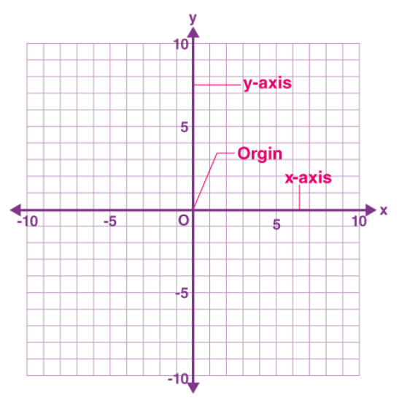

So that the origin that is the point (0,0) form the basis for all the other functions of the program to be specified, For an instance creation of a line requires two points to be used, Therefore both the points, if given vertices can find the exact length of the line, Area and perimeters of different figures to be used. Now here come the part of Full flagged geometric knowledge.

Point Snap:

The vertex of the mouse at any point in the Cartesian plane should be provided and shown either in a hovering box or at a status bar to be made at the bottom of the UI, to the X and Y coordinates of the point snap.

These points are further to be used in making of other figures whose functions are detailed below in the coming points.

Line:

Simple Line: A line can be created using two points. First point can be used as a starting point and further use the second point to use as the ending point of the line.

Multipoint Line: A multi-point line can be created by clicking on different points and the line should be automatically joint to make a connected of semi connected figure.

Drawing a Circle:

A Circle can be drawn by various means by the end user. Some of such methods are:   
1. Center Radius Circle: In this making of circle 1st point is to be taken as the center of the circle in the Cartesian plane. Now the other point has to be taken as the length of the radius required.

2. Two-point Circle: In this making of circle 1st point is to be taken as the first tangent to the circle in the Cartesian plane. Now the other point has to be taken as the Second tangent to the circle and can be also used to set the size of the circle.

As the current application proposed is a basic program with various possibilities, we are implementing a Center Radius Circle. Now as we are using the Cartesian plane we can now find the location of the points on the drawing.

Drawing a quadrilateral:

There are different forms of quadrilaterals but the most common one used are to be given the privilege of easy creation in the program so the user finds it faster to draw images.

General quadrilaterals include:

1. Square
2. Rectangle
3. Rhombus

Now these above quadrilaterals are to be given certain shortcuts so as the user finds it easy to implement them in the drawing.

Other Shapes Even more than four sides can be implemented using a multi-point line.

Eraser: An eraser should be the part of the program so as to make the user free to draw and delete any part of the drawing.

Size Constraint for brush size and Eraser: There should be a universal or right click write size-based mechanism so as to make the user enter the size of the brush as well as the eraser size to increase or decrease the thickness.

Select Tool: A select tool should be available in the system tray so as to select the part of the drawings that can be moved of copied.

Copy/Cut: The program should be able to copy the selected part of the image in the system clipboard.

Paste: The program should have a clear capability to paste any type of image data, into the drawing.

**OPEN ISSUES**

Color picker:

Now, it is currently not decided whether to implement a color filler. Whether picker to be used should be able to pick from the whole Screen Snapshot or only from the drawing.

Color filler: The filler should be able to fill the closed figures with the color specified.

Color Pallet: The color pallet is a drop down with different shades of colors available to change the brush color and filler.

**Success Metric:**

The project is based on the general requirement of the people from different backgrounds, whether it be a Digital Painters, Architects, Business Professionals, Photographers, Engineers whether they be from Civil, Graphics Designers, Computer Engineers or from most other fields, the proposed program is to provide overall basis for each and every image editing and creation.

1. **ARCHITECTURAL SPECIFICATION**

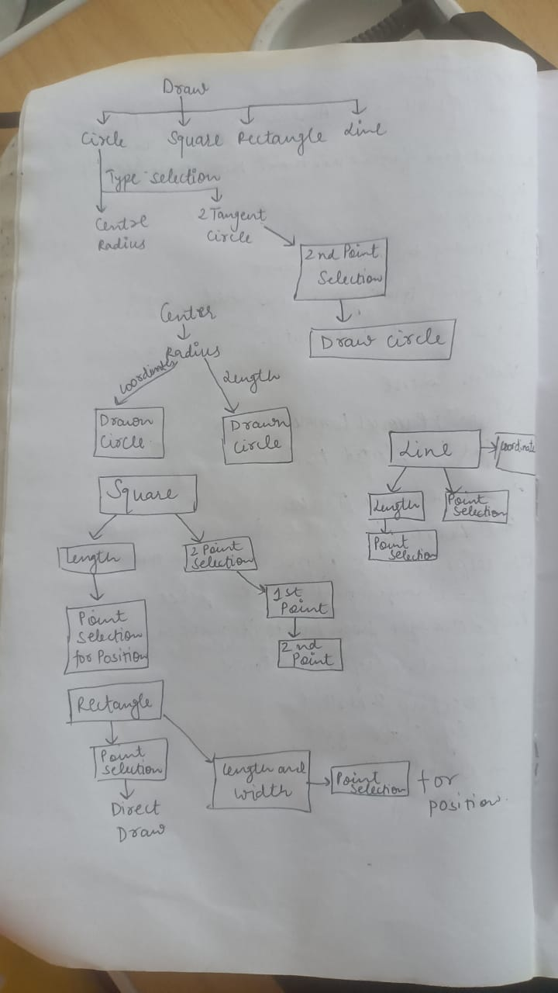

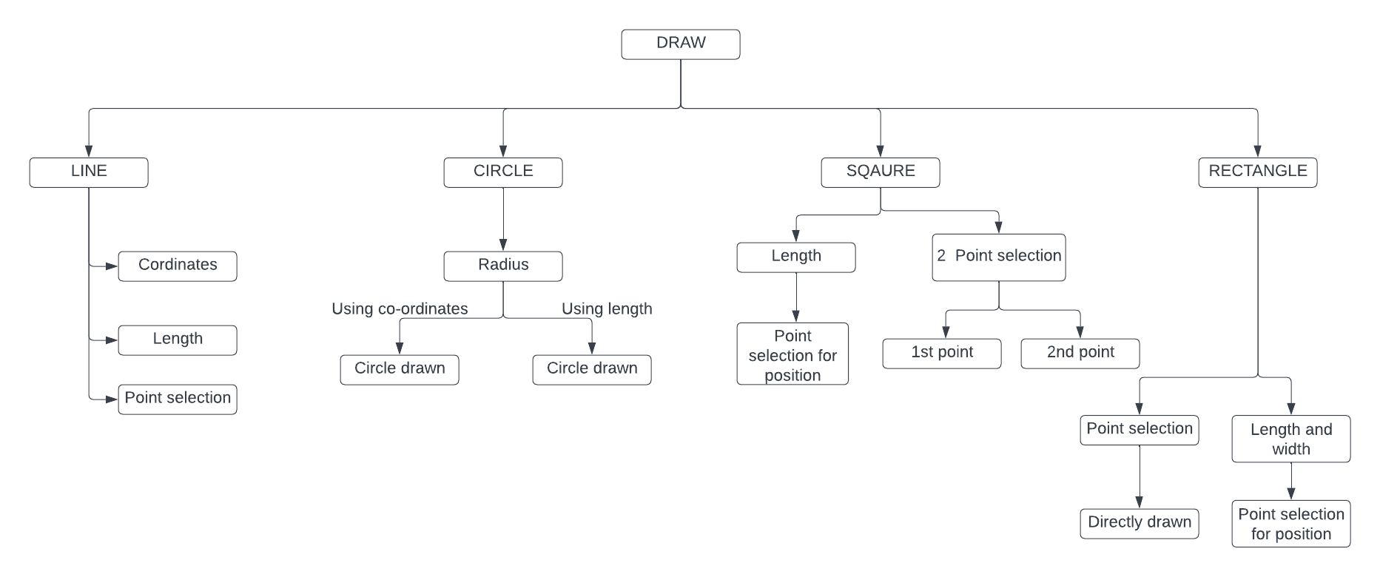

This is what we are planning to implement at the very moment, but we definitely we have a lot more planned for the next versions. And to be very clear this isn’t the final UI design or the final diagram, this is just to make you understand the basic idea of our project.